Bilar "Bill" Saruun

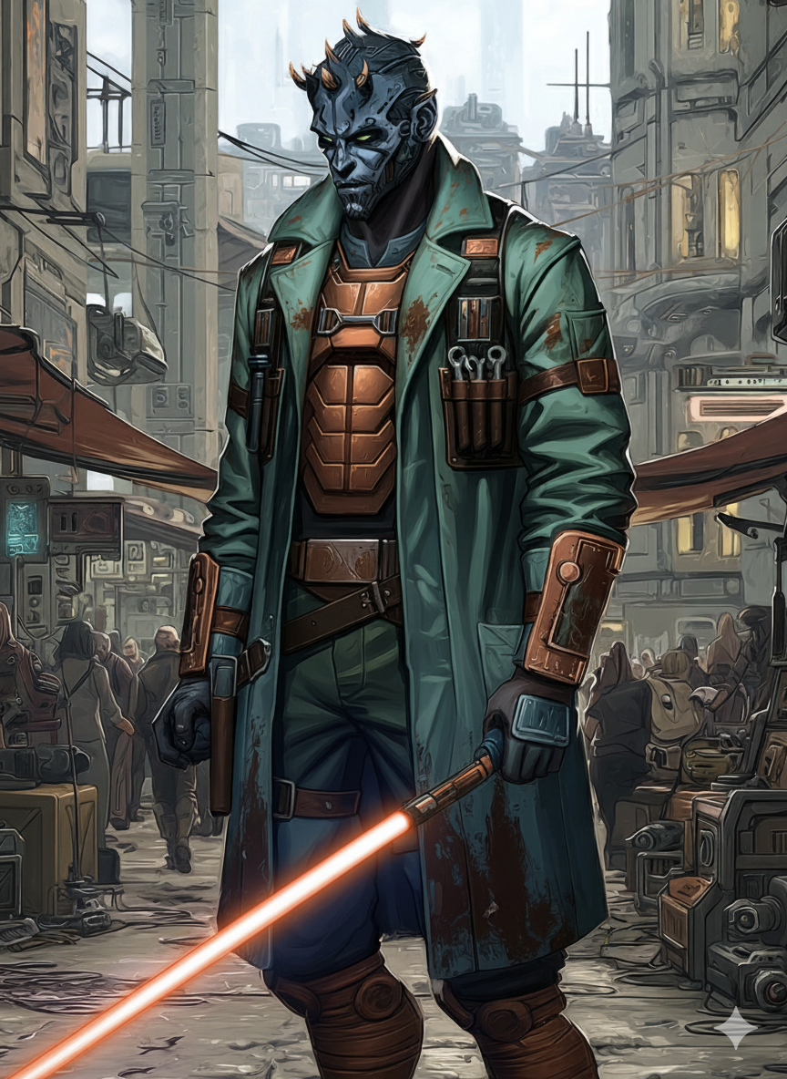
The maintenance shaft was three meters wide and ran the length of the Temple's southern wall. Bilar had hidden there during meditation sessions when the Force felt too loud in his head. Master Koras always found him. Always sat quietly until Bilar was ready to return. Never scolded. Simply said, "The Force speaks differently to everyone. Learn your own language."
On the day the clones came, Master Koras shoved him into that same shaft. "Run," she said. "Do not look back. Do not reach out through the Force. Become nobody. Survive." Her lightsaber was already igniting as she turned to face the troopers. The last lesson. The hardest lesson.
Bilar ran. Through maintenance shafts. Through drainage pipes. Through sections of the Temple he had never seen. Behind him, the Force screamed. His training bond with Master Koras went cold. Not severed. Simply absent. Like a limb suddenly missing.
He emerged two kilometers from the Temple in a waste processing district. His robes went into an incinerator. His Padawan braid followed. His lightsaber stayed. He could not let it go. Not yet. He wrapped it in stolen work clothes and became another Zabrak youth looking for employment.
The name had to change. Bilar Saruun appeared in Temple records. The Empire would have those records. He became Bill. Just Bill. No surname. No history. Dock workers did not ask questions if you could lift cargo and keep quiet.
For three years he moved from port to port. Never staying long. Never making friends. The Force whispered constantly but he never answered. Answering meant remembering. Remembering meant feeling the empty space where his training bond had been. Where dozens of bonds had been. The Temple had been a web of connections through the Force. Now there was silence.
He hid his lightsaber in whatever ship would take him on. Wrapped in coolant tape. Tucked behind power converters. Looking like spare parts nobody would investigate. At night, in cargo holds or empty corridors, he practiced forms. Moving meditation. The only connection to his past he allowed himself. His body remembered what his mind tried to forget.
The YT-1300 job came through a freight broker who did not ask for documentation. Tekli needed hands for loading. Bill needed a bunk and meals. Simple transaction. No questions. No connections.
Tekli was different from other captains. The Chadra-Fan talked to his ship like it could hear him. Treated it like a partner rather than property. There was honesty in that. Bill appreciated honesty. It had become rare.
The work was straightforward. Load cargo. Secure cargo. Unload cargo. Do not ask what was in the crates. Do not ask why they avoided Imperial checkpoints. Do not ask why medical supplies needed to be smuggled to planets the Empire controlled. Just work. Just survive.
The Force noticed things Bill tried to ignore. How Tekli's modifications were impossibly precise. How their routes always found gaps in Imperial patrols. How the cargo they carried saved lives. The Force suggested patterns. Bill refused to see them.
Then Kaa'Reth joined. The Verpine slicer who made their documents perfect. Who looked at Bill sometimes like he was solving an equation. Who never asked questions but clearly had answers. Bill stayed careful. Moved normally. Reacted slowly. Played dumb when necessary.
Ragath arrived last. Professional soldier's bearing. Mercenary's ethics. He protected the crew because that was his job. He noticed everything but commented on little. Bill recognized the type. Trained killers who chose their battles carefully. Dangerous but not cruel. Practical but not heartless.
The message came through a shipping manifest three months after Ragath joined. Hidden in weight calculations where only someone checking math would notice. A Temple proverb in ancient Jedi code: "The river finds its way to the sea." Master Koras had used it when teaching about patience. About inevitability. About the Force's will.
Bill memorized the coordinates. Deleted the manifest. Told the crew he needed supplies. Personal items. Would be back before departure. They did not question it. Everyone had secrets on the YT-1300.
The warehouse was empty except for a single datapad on a crate. No presence in the Force. No watchers. Just the pad and the dust and the sound of distant traffic.
The message was brief: "Your master's last confirmed location: Imperial black-site transfer, designation K-7742. Prisoner transport logs indicate Force-sensitive cargo. Supply chain intersects with courier route INX-4. Upcoming operation will intercept this route. Participation provides access to transport records. Kestrel remembers the Temple. Kestrel remembers the fallen. Choose."
The pad self-destructed after reading. Bill stood in the empty warehouse for seventeen minutes. Master Koras might be alive. Might be imprisoned. Might be experimented on. Might be anything except at peace. The thought burned like acid in his stomach.
He returned to the ship. Said nothing. When Kestrel's next job came through, Bill worked harder. Loaded faster. Watched sharper. Every credit earned was a step closer to the truth. Every Imperial target they undermined was a small justice for the Temple.
When Kestrel announced the courier mission, Bill volunteered immediately. The others looked surprised. Bill never volunteered for anything. He met their looks steadily. "Good credits," he said. "Worth the risk."
Tekli nodded. Kaa'Reth calculated. Ragath shrugged. They would all go. For their own reasons. With their own goals. Bill's goal sat in an Imperial database on that courier. Transport records. Prisoner manifests. The truth about Master Koras.
His lightsaber waited in its hiding place. Wrapped in coolant tape. Disguised as spare parts. He had not ignited it since the Temple. But if Master Koras lived, if she was on that transport route, if the Empire held her, then Bill would remember how to be Bilar Saruun. He would remember how to be a Jedi.
The Force whispered agreement. Or warning. Bill could not tell the difference anymore. Maybe there was not one.
He practiced forms in the dark cargo hold. Moving meditation. Preparing for violence. Preparing for truth. Preparing for whatever came next. The movements were perfect. Three years of practice in hidden spaces had maintained his skills. His body remembered what it meant to fight for something beyond survival.
Master Koras had saved him. Pushed him into that maintenance shaft. Faced the clones alone. Now Bill might have a chance to return the gesture. Or at least learn her fate. Either was better than not knowing. Better than the silence where their bond had been.
The mission would begin soon. Bill would be ready. Just another dock worker. Just another pair of hands loading cargo. Until the moment he needed to be something more.
The Force would tell him when. It always did. Even when he tried not to listen

